SRI CHANDRASEKHARENDRA SARASWATHI VISWA MAHAVIDYALAYA

(UNIVERSITY ESTABLISHED under section 3 of UGC Act 1956)

ENATHUR, KANCHIPURAM – 631 561



OBJECT ORIENTED PROGRAMMING IN JAVA

LABORATORY RECORD

Name : S . VISHALI

Reg. No : 112534055

Class : I YEAR BCA

Subject : UCAF252T50 – OOP in Java Lab

SRI CHANDRASEKHARENDRA SARASWATHI

VISWA MAHAVIDYALAYA
(University Established under section 3 of UGC Act 1956)



BONAFIDE CERTIFICATE

This is to Certify that this is the bonafide record of work done by Mr. S.VISHALI , with Reg. No 112534055 of I Year BCA in the Object Oriented Programming in Java Lab during the year 2026.

Staff-in-charge Head of the Department

Submitted for the Practical Examination held on ________________________

Internal Examiner External Examiner.

INDEX

S.No. | Date | Title | Page No. | Signature
1 | 05 Feb 2026 | PROGRAM USING CLASS, OBJECT, OVERLOADED METHODS, COMMAND LINE ARGUMENTS | 01
2 | 12 Feb 2026 | PROGRAM TO EXPLORE JAVA.LANG.MATH CLASS METHODS AND CUSTOM PACKAGE | 03
3 | 12 Feb 2026 | PROGRAM TO EXPLORE STRING AND STRINGBUFFER METHODS
4 | 19 Feb 2026 | PROGRAM TO DEMONSTRATE INHERITANCE,  DYNAMIC DISPATCH CONCEPTS
5 | 26 Feb 2026 | PROGRAM TO EXPLORE BUILT IN EXCEPTIONS AND STATIC METHODS
6 | 05 Mar 2026 | PROGRAM TO EXPLORE USER-DEFINED (CUSTOM) EXCEPTIONS
7 | 26 Mar 2026 | PROGRAM TO EXPLORE MULTI THREADING
8 | 26 Mar 2026 | PROGRAM TO EXPLORE FILE OPERATIONS
9 | 02 Apr 2026 | PROGRAM TO EXPLOREL COLLECTIONS FRAMEWORK (DATASTRUCTURES) AND JAVADOC
10 | 09 Apr 2026 | SAMPLE GUI WITH EVENT HANDLING USING JAVA SWINGS
11 | 16 Apr 2026 | DATABASE PROGRAMMING WITH JAVA.SQL

1 | PROGRAM USING CLASS, OBJECT, OVERLOADED METHODS, COMMAND LINE ARGUMENTS | 05 Feb 2026

AIM:
To demonstrate the use of classes, packages, method overloading, and command-line arguments in Java.

UML DIAGRAMS:
Package Diagram:
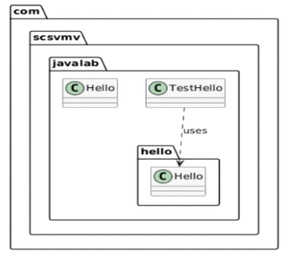

Class Diagram:
com.scsvmv.javalab.hello.Hello
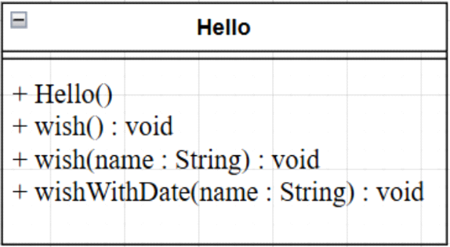

com.scsvmv.javalab.Hello
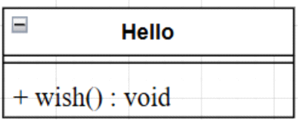

com.scsvmv.javalab.TestHello
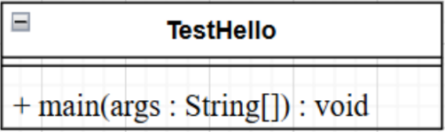

Folder structure:
src/
└── com/
└── scsvmv/
└── javalab/
├── Hello.java
├── TestHello.java
└── hello/
└── Hello.java

SOURCE CODE:

https://github.com/vishalis2007/JAVA-LAB/tree/main/program1/javalab

Steps to Compile the Program
- Open Command Prompt / Terminal
- Navigate to the src folder using cd command
- Compile all Java files
Note: Always compile from the src folder, not inside package folders.
…..src>javac com/scsvmv/javalab/hello/Hello.java
…..src>javac com/scsvmv/javalab/Hello.java
…..src>javac com/scsvmv/javalab/TestHello.java

✔ .class files will be generated in the same package folders.

Steps to Run the Program

Run with command-line argument:
java com.scsvmv.javalab.TestHello Seetharaman

If no argument is passed:
java com.scsvmv.javalab.TestHello

Sample Output (with argument)
Hello World
Hello Vishali
Hello Vishali | Date: Thu Feb 05 10:30:15 IST 2026

Output (without argument)
Hello World
Usage:
java com.scsvmv.javalab.TestHello <name>
Example:
java com.scsvmv.javalab.TestHello Vishali

OUTPUT:

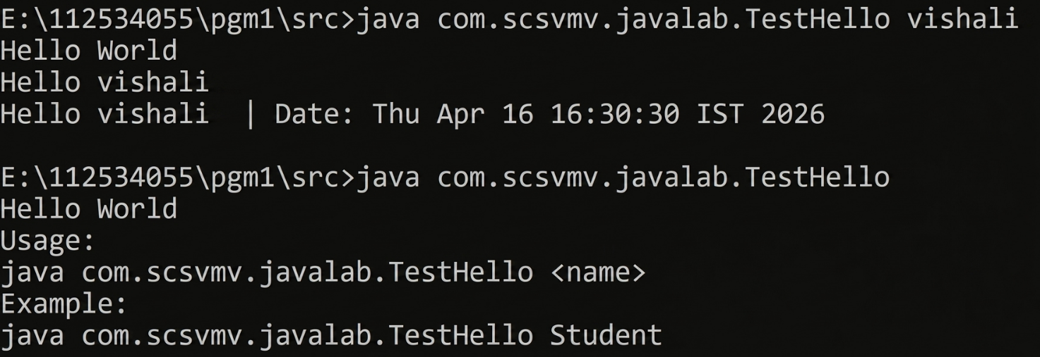

2 | PROGRAM TO EXPLORE JAVA.LANG.MATH CLASS METHODS AND CUSTOM PACKAGE | 12 Feb 2026

AIM:
To demonstrate the use of important methods in java.lang.Math class and to experiment custom packages in Java.

UML DIAGRAMS:
Class Diagram:
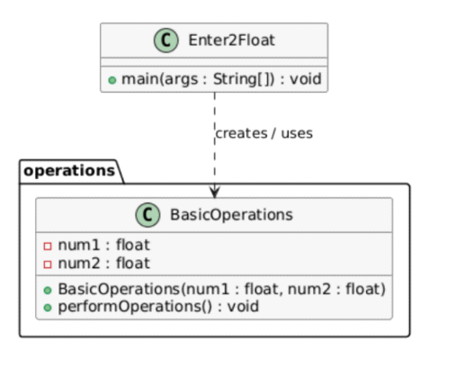
Sequence Diagram:
₌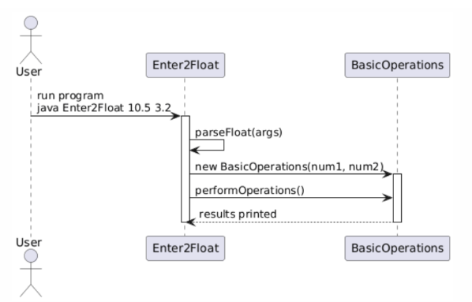

Package Diagram:

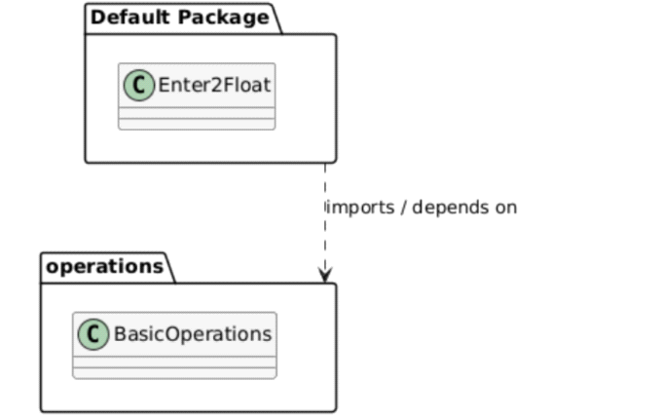

SOURCE CODE:

https://github.com/vishalis2007/JAVA-LAB/tree/main/program2

OUTPUT:
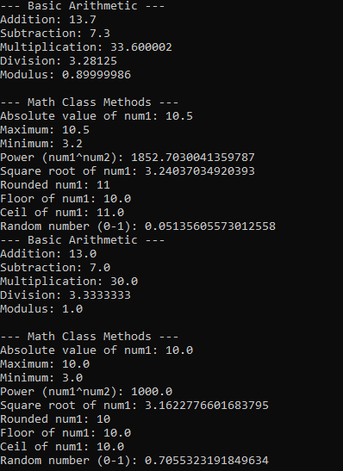

3 | PROGRAM TO EXPLORE STRING AND STRINGBUFFER METHODS | 12 Feb 2026

AIM:
To demonstrate the use of String and StringBuffer methods in Java using command-line arguments.

UML DIAGRAMS:
Class Diagram
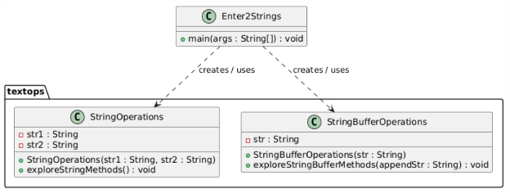

Package Diagram
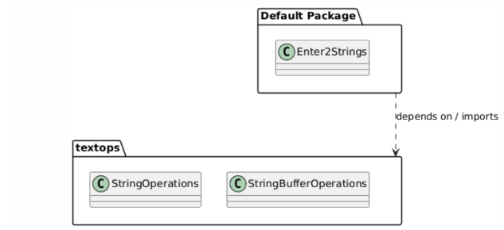
Sequence Diagram
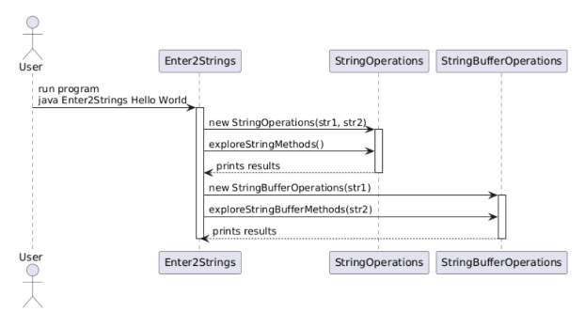

SOURCE CODE :

https://github.com/vishalis2007/JAVA-LAB/tree/main/program3

OUTPUT:
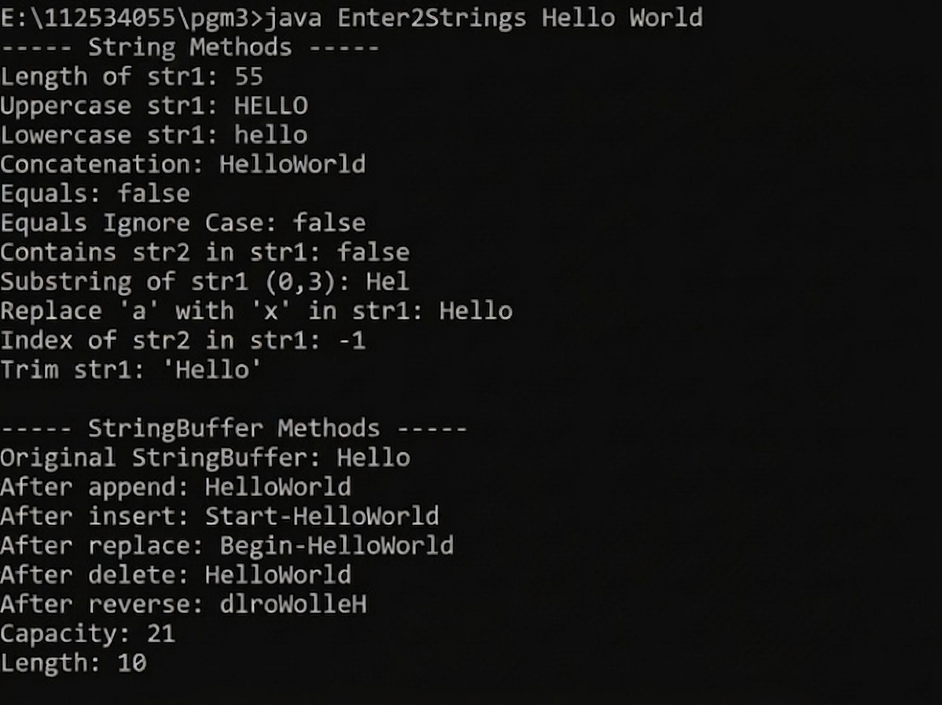

4 | PROGRAM TO DEMONSTRATE INHERITANCE,  DYNAMIC DISPATCH CONCEPTS | 19 Feb 2026

AIM:
To demonstrate interfaces, inheritance, polymorphism (static & dynamic), and use of super keyword in Java.
UML DIAGRAMS:
Package and Class Diagram:
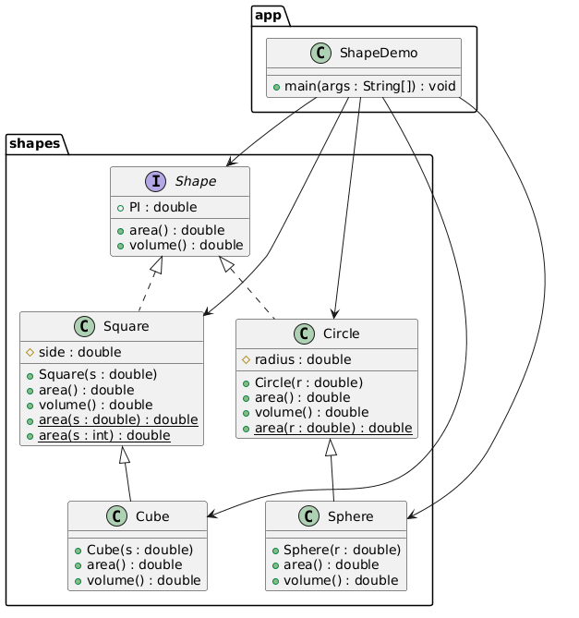

Sequence Diagram:
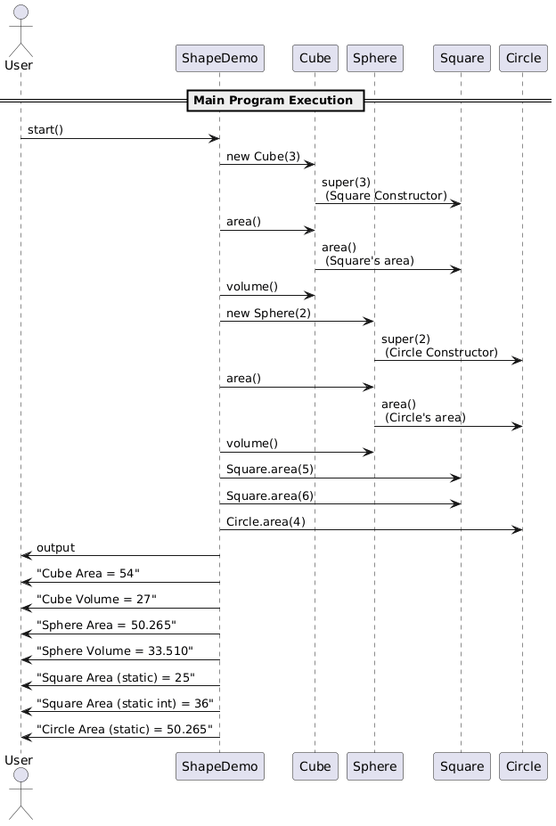

SOURCE CODE:

https://github.com/Thxrnesh777/JavaLab/tree/main/Program4

OUTPUT:

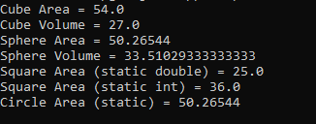

5 | PROGRAM TO EXPLORE BUILT IN EXCEPTIONS AND STATIC METHODS | 26 Feb 2026

AIM:
To demonstrate built-in exception handling and the use of static methods in Java.

UML DIAGRAM:

Class Diagram:
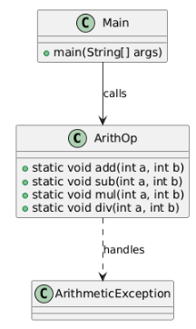
Sequence Diagram:

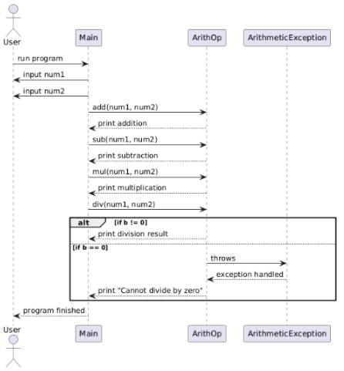

SOURCE CODE:

https://github.com/vishalis2007/JAVA-LAB/tree/main/pgm5

OUTPUT:
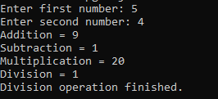

6 | PROGRAM TO EXPLORE USER-DEFINED (CUSTOM) EXCEPTIONS | 05 March 2026

AIM:
To demonstrate custom exception in Java.

UML DIAGRAM:

Class Diagram:

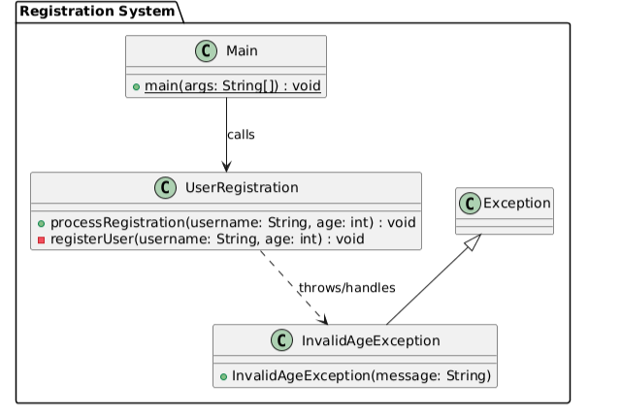

Sequence Diagram:
Failure scenario

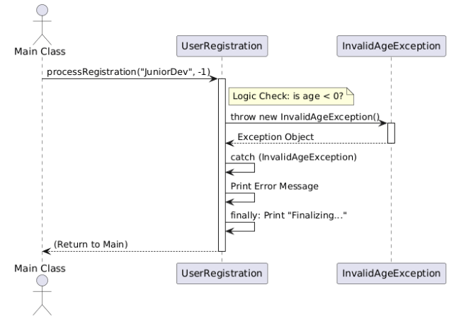

Sequence Diagram: Success Flow

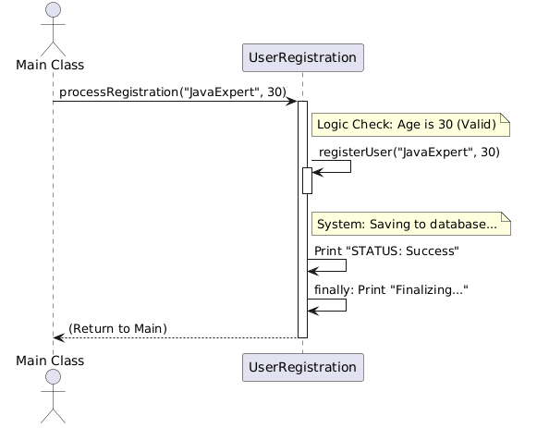

SOURCE CODE:

https://github.com/vishalis2007/JAVA-LAB/tree/main/pgm6

OUTPUT:

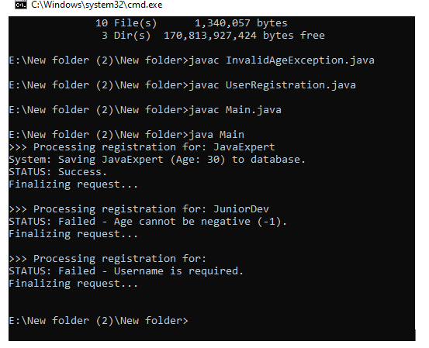

7 | PROGRAM TO EXPLORE MULTI THREADING | 26 March 2026

AIM:
To demonstrate Multithreading in Java.

UML DIAGRAM:

Class Diagram:

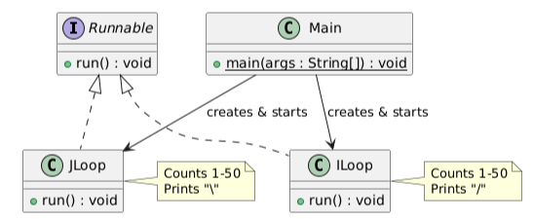
Sequence Diagram:
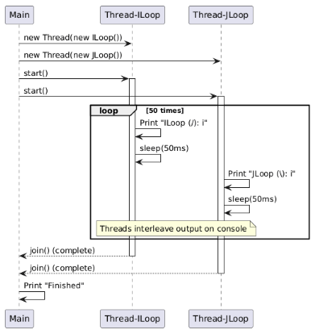
SOURCE CODE:

https://github.com/vishalis2007/JAVA-LAB/tree/main/pgm7

OUTPUT:
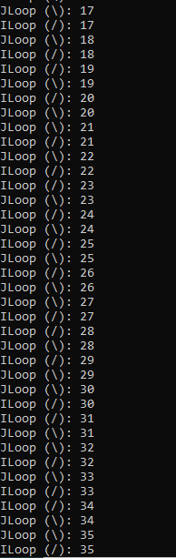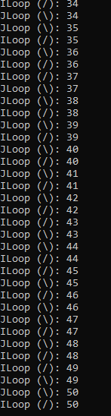

]
8 | PROGRAM TO EXPLORE FILE OPERATIONS | 26 March 2026

AIM:
To demonstrate File Operations using java.io package classes in Java.

UML DIAGRAM:

Class Diagram:
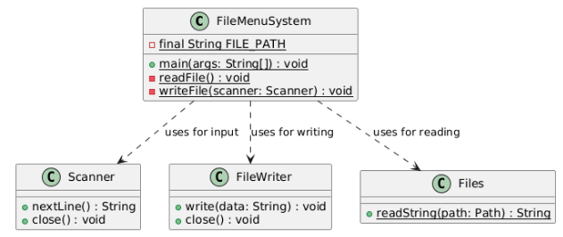
Activity Diagram:
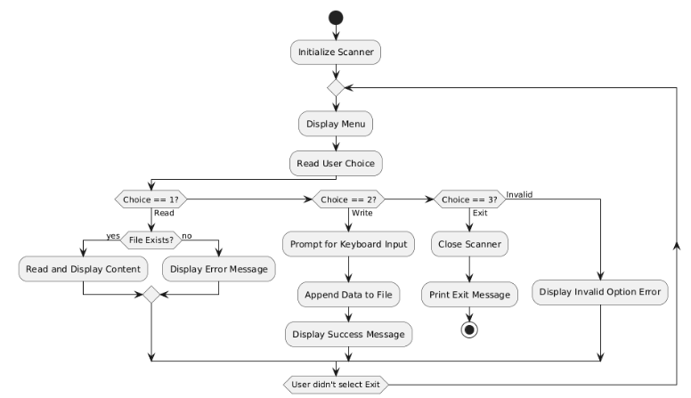
SOURCE CODE:

https://github.com/vishalis2007/JAVA-LAB/tree/main/pgm8

OUTPUT:

9 | PROGRAM TO EXPLOREL COLLECTIONS FRAMEWORK (DATASTRUCTURES) AND JAVADOC | 02 Apr 2026

AIM:
To demonstrate Data Structure Operations using java.util collections framework and to experiment Javadoc feature.

UML DIAGRAM:
Class Diagram:
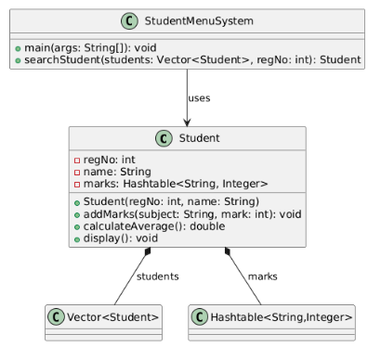
Use Case Diagram:
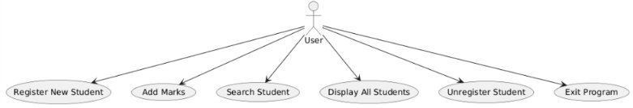

Activity Diagram:
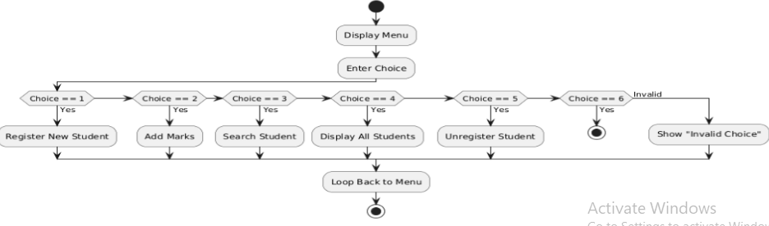

Sequence Diagram (addMarks()):
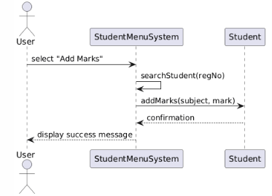

SOURCE CODE:

https://github.com/vishalis2007/JAVA-LAB/tree/main/pgm9

OUTPUT:

10 | SAMPLE GUI WITH EVENT HANDLING USING JAVA SWINGS | 09 Apr 2026

AIM:
To demonstrate java Graphical User Interface and Event handling features using javax.swing components.

UML DIAGRAM:

Package and Class Diagram:
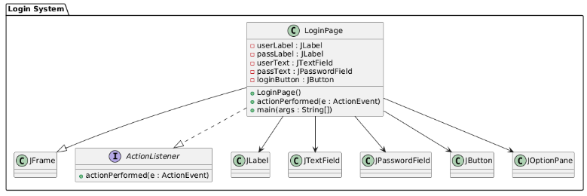
Sequence Diagram:
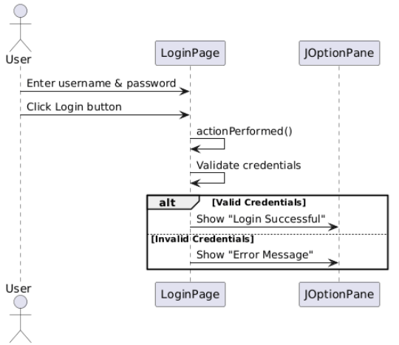

SOURCE CODE:

OUTPUT:
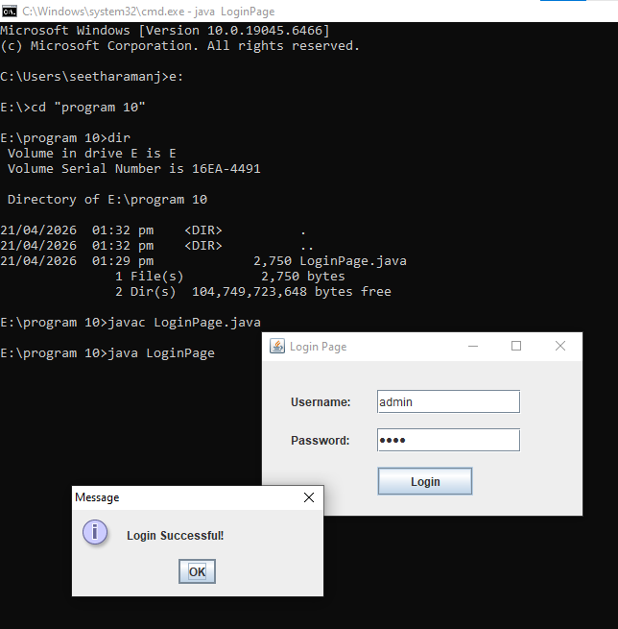
11 | DATABASE PROGRAMMING WITH JAVA.SQL | 16 Apr 2026

AIM:
To demonstrate data base connectivity capabilities with java.sql and mysql

UML DIAGRAM:
Class Diagram:
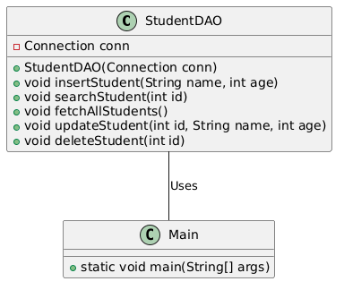
Component Diagram:
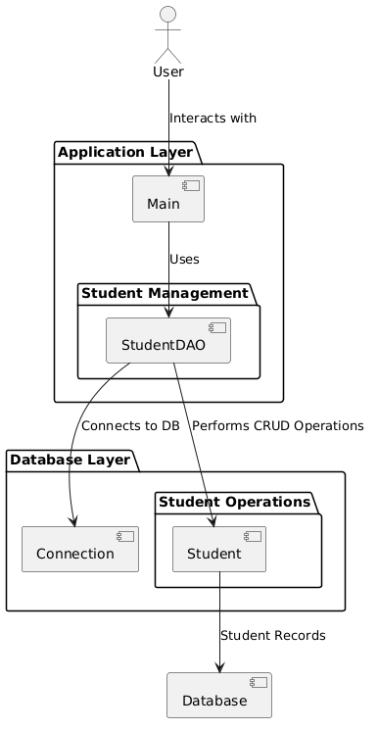

Sequence Diagram – Insert:
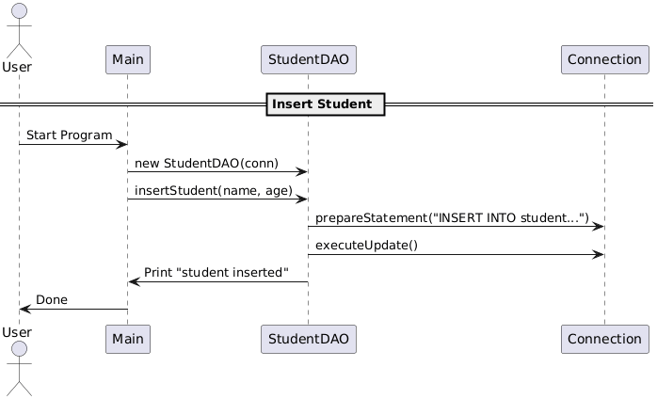

Project Structure:
StudentApp/
├── src/
│ ├── Main.java
│ └── StudentDAO.java
├── db.properties
├── lib/
│ └── mysql-connector-java-8.x.x.jar

db.properties:
db.url=jdbc:mysql://localhost:3306/school
db.user=root
db.pass=password

